Great Gatsby Film Assignments/Multigenre Writing Approach
Instructions: While watching the film, choose two of the following options to complete. EVERYONE is required to make the timeline (plus the other two options). These are due MONDAY, APRIL 9 at the beginning of the hour.
- List ALL the main characters and write a three sentence description for each.
- Write a text conversation between Daisy and Gatsby after they are reunited for the first time. Write at least 5 texts from each character.
- Make a timeline of the film, starring the 10 most important events. Use words and pictures.
- Draw a cartoon version of one of Gatsby’s parties with at least three characters from the film labeled (one full page).
- Make a graffiti drawing using one of the character’s names. In the letters, draw objects, write words and phrases that represent that character (see example below).
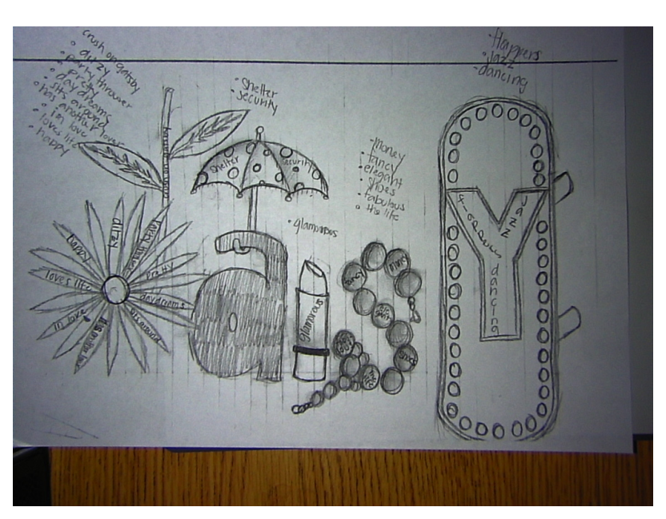
- If you were to create a modern day version of this film, write a paragraph description of Gatsby’s mansion, Nick’s house, and Daisy’s home as they would appear THIS YEAR (3 paragraphs total).
- Write a song or poem that uses 5 quotes from the film. The poem must be 15 lines long.
- Create three journal entries from one of the character’s points of view as they progress through the story. The entries must be 5-7 sentences EACH. Be sure to cite important events.
- Staying true to the characters, draw a modern day version of one character’s outfits and hairstyles (at least three different IN COLOR). Write caption descriptions of each one.
- Create a board game for The Great Gatsby. Use important places, characters, and plot. Include rules (typed), board, color, creativity and the game should be able to be played. This counts as BOTH choices if you complete this activity.
- Make your own video version of one of the scenes in Gatsby. Post to YouTube for Mrs. Wisehart to access.
- Draw a map of the geography of the film using color, pictures and a key explaining what everything is.
- Do you have an idea? It needs to be approved.
